Simplex Algorithm:
Linear Programming represents a somewhat radical departure from methodologies of algorithms we've explored in this class so far. Instead of approaching algorithms from a computer science point of view, we know look at optimization problems from the perspective of mathematics. Specifically, LP uses the language of matrices and the power of linear algebra, geometry and calculus (in disguise) to solve an optimization problem given a set of constraints. To set up LP problems we use a standard form defined by four components:
1) x is a column vector of variables to solve for, all of which are non-negative. 2) c is a column vector of linear coefficients. 3) b is a column vector of linear constraints. 4) A is a matrix, with each row representing linear coefficients of x that results in a value less than or equal to the corresponding row in b. Put simply we can define an LP as: LP = {Max c^{T}x , subject to Ax <= b , given that x >=0}. Note the first term c^{T}x is called the objective function. This lecture lays out a nice foundation for what this equation means and how to transform some of the problems we've seen in this course into the standard form.
Translating an LP problem into the standard form is only half the battle, we now need to solve for optimal values of x. Here we diverge from computer science and leverage geometric reasoning to solve the LP. As the course content showed, we can construct a polytope containing all feasible solutions to the LP by plotting the intersection of each row in Ax <= b. The intuition behind the simplex algorithm is to walk along the boundary of the polytope to find the points that maximize the objective function. We start this walk at the origin, since in the standard form all values in x are non-zero (you can thing of each axis as being one of the bounding lines formed by the x >= 0 constraint).
While it might sound simple, the process of converting this geometric reasoning into an algorithm is quite complex. We start by translating the LP into a slack form shown by this transformation:
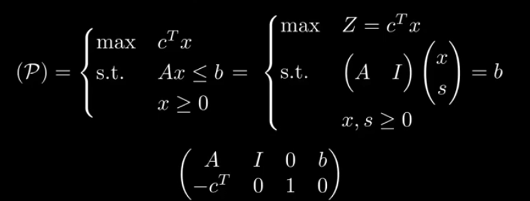
We then define a pivot matrix:
Note that this a concise matrix representation referred to as a tableau, expanding A, I and b out show shows that the first n columns represent variables x₁ to x_{n} , and next group of the columns refer to the slack variables, and the last column refers to the inequality constraint value. We also see that the bottom row refers to the objective function and the rest of the rows refer to specific constraints.
At each iteration of the simplex algorithm, we perform a pivot rule to transform the tableau in a way that represents finding the nearest neighbor that results in a greater objective function. The pivot rule starts by finding the column with the minimum negative element in the bottom row of the tableau, this becomes the pivot column. The pivot row is the row with the lowest non-negative ratio of the last column (b_{i}) and the value in the pivot column. We define the pivot point to be at (pivot row, pivot column) and we divide all the values in the row by the pivot point. We also zero out the other terms in the column by repeatedly subtracting the pivot row from the row. Honestly, I found writing through this code to be helpful in figuring out what is going on. Below is a sketch of the simplex code so far. As we see the algorithm terminates when it the objective function row contains no negative values.
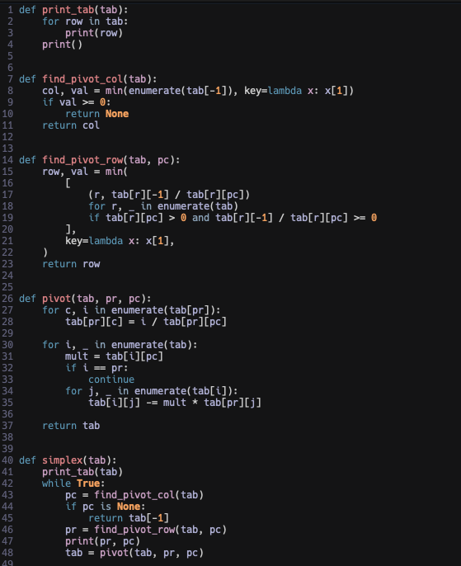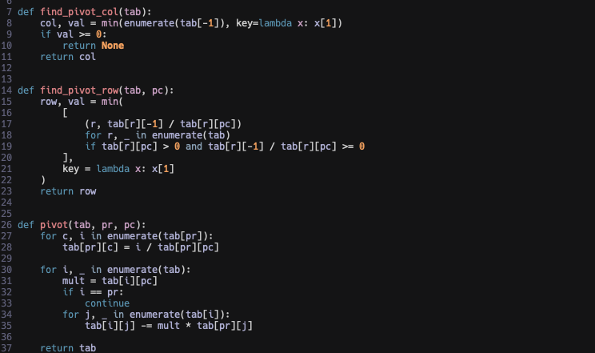
Citations:
[1] https://en.wikipedia.org/wiki/Linear_programming
[2]https://www.youtube.com/watch?v=WwMz2fJwUCg
[3] https://www.youtube.com/watch?v=ostCDQlBiB8

